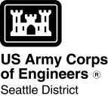
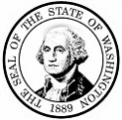
AGENCY USE ONLY

Date received:

Agency reference #:
Tax Parcel #(s):

WASHINGTON STATE
Joint Aquatic Resources Permit
Application (JARPA) [help]

Attachment D:
Construction sequence [help]
TO BE COMPLETED BY APPLICANT [help]

Project Name:
Location Name (if applicable):

Use this attachment only if your project will be constructed in phases or stages. Complete the outline showing the construction sequence and timing of activities, including the start and end dates of each phase or stage.
Use black or blue ink to enter answers in white spaces below.
Phase  or  Stage | Start Date | End Date | Activity Description

If you require this document in another format, contact the Governor’s Office for Regulatory Innovation and Assistance (ORIA) at
(800) 917-0043. People with hearing loss can call 711 for Washington Relay Service. People with a speech disability can call
(877) 833-6341. ORIA publication number: ORIA-16-015 rev. 10/2016

